Irregular-base Pyramid

Definition
# Source: AI Source: Provided by: [Data Path: Persons Table -> ID Column: 1, Name_En Column: Motasem Essam] -> From: [ChatGPT] on [7/25/2026]
An irregular-base pyramid is a three-dimensional geometric solid whose base is an irregular polygon and whose lateral faces are triangular regions meeting at a common point called the apex.
An irregular polygon does not have all its sides and interior angles equal. Therefore, an irregular-base pyramid has a base whose side lengths or interior angles are not all equal.
The apex may be positioned directly above a selected point in the base plane or offset from that point. Consequently, an irregular-base pyramid may have different lateral edge lengths and triangular face areas.
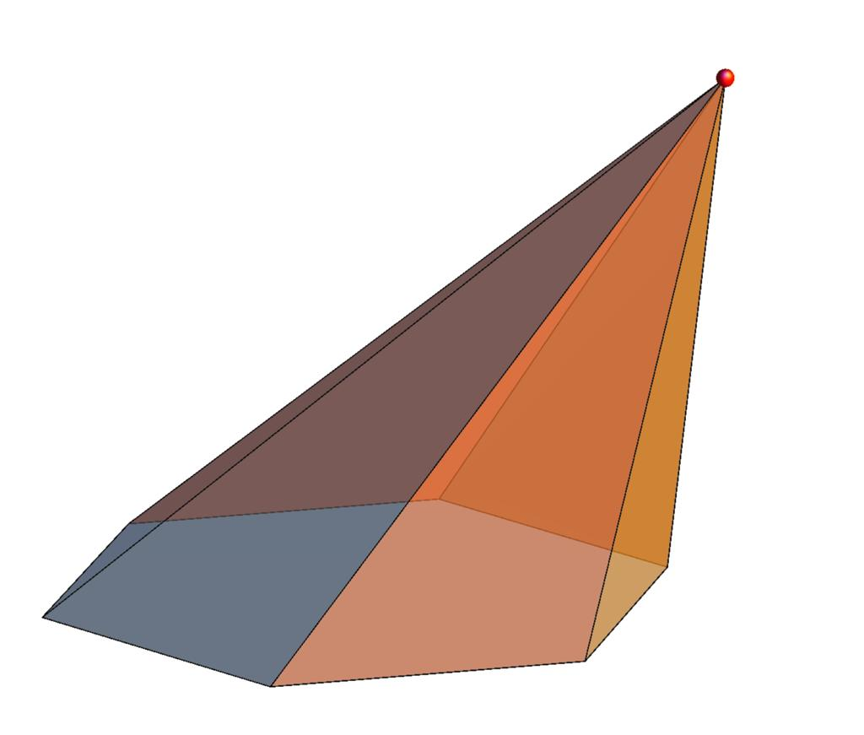
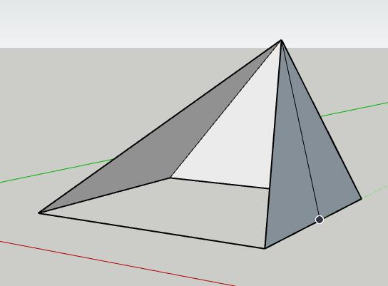
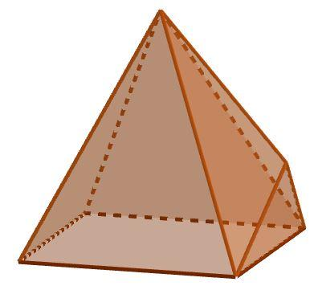

Simple Definition
# Source: AI Source: Provided by: [Data Path: Persons Table -> ID Column: 1, Name_En Column: Motasem Essam] -> From: [ChatGPT] on [7/25/2026]
An irregular-base pyramid is a pyramid whose base is a polygon with sides or angles that are not all equal.
For example, a pyramid with an irregular pentagonal base has five base edges of potentially different lengths and five triangular lateral faces meeting at one apex.

Classification Tree
# Source: AI Source: Provided by: [Data Path: Persons Table -> ID Column: 1, Name_En Column: Motasem Essam] -> From: [ChatGPT] on [7/25/2026]
Pyramids by Base Regularity
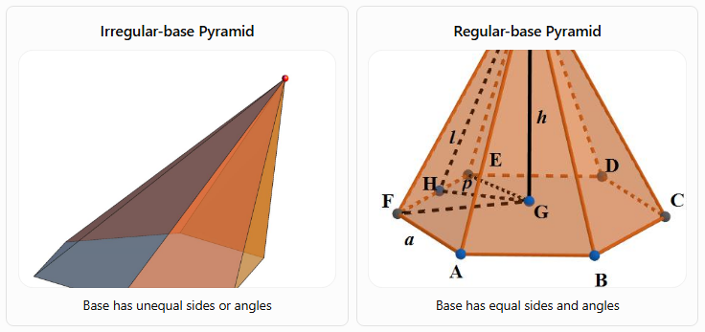
Irregular-base Pyramid
Base has unequal sides or angles
Regular-base Pyramid
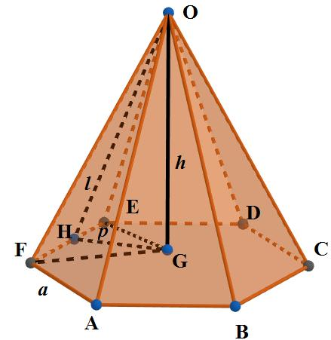
Base has equal sides and angles
A. By Number of Base Sides
An irregular-base pyramid can have different polygonal bases:
- Irregular triangular pyramid: Has a scalene or non-equilateral triangular base.
- Irregular quadrilateral pyramid: Has an irregular four-sided base.
- Irregular pentagonal pyramid: Has an irregular five-sided base.
- Irregular hexagonal pyramid: Has an irregular six-sided base.
- Irregular \(n\)-gonal pyramid: Has an irregular polygon with \(n\) sides.
A triangular base is irregular if its sides or angles are not all equal. For triangles, an equilateral triangle is regular; an isosceles triangle with unequal side lengths is irregular as a polygon.
B. By Spatial Orientation
- Right pyramid with an irregular base: The perpendicular from the apex meets the base at a designated center or reference point. For irregular bases, the meaning of center must be specified because there is no single universally appropriate center for every irregular polygon.
- Oblique pyramid with an irregular base: The apex is positioned away from the chosen base reference point, producing an oblique configuration.
The regularity of the base and the position of the apex are separate properties.

Key Characteristics
# Source: AI Source: Provided by: [Data Path: Persons Table -> ID Column: 1, Name_En Column: Motasem Essam] -> From: [ChatGPT] on [7/25/2026]
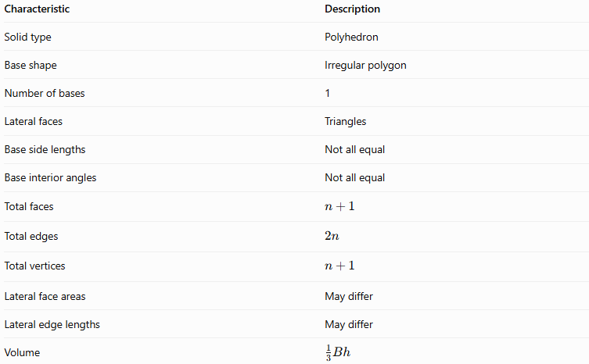
Characteristic | Description
Solid type | Polyhedron
Base shape | Irregular polygon
Number of bases | 1
Lateral faces | Triangles
Base side lengths | Not all equal
Base interior angles | Not all equal
Total faces | $$n+1$$
Total edges | $$2n$$
Total vertices | $$n+1$$
Lateral face areas | May differ
Lateral edge lengths | May differ
Volume | $$\frac{1}{3}Bh$$
Here, $n$ is the number of sides in the base, and $h$ is the perpendicular height.

Geometric Representation
# Source: AI Source: Provided by: [Data Path: Persons Table -> ID Column: 1, Name_En Column: Motasem Essam] -> From: [ChatGPT] on [7/25/2026]
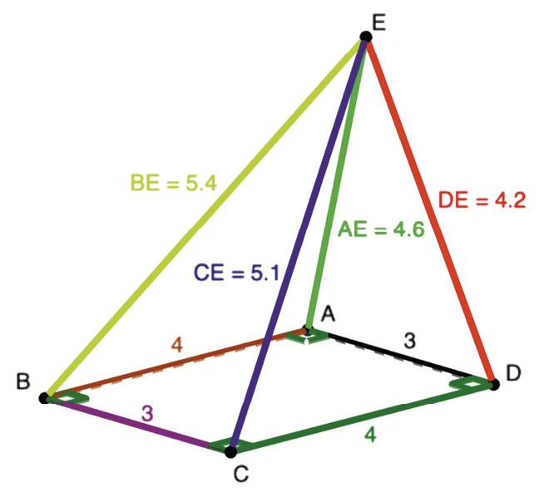
Consider a pyramid with an irregular pentagonal base $ABCDE$ and apex $S$.
Its main components are:
- Base $ABCDE$: An irregular pentagon.
- Apex $S$: The common vertex of all lateral faces.
- Base edges: $AB,BC,CD,DE,$ and $EA$.
- Lateral edges: $SA,SB,SC,SD,$ and $SE$.
- Lateral faces: Triangles $SAB,SBC,SCD,SDE,$ and $SEA$.
- Height $h$: The perpendicular distance from the apex to the plane containing the base.
- Slant heights: The perpendicular distances from the apex to individual base edges, measured within their respective triangular faces. These distances can differ from face to face.
Because the base is irregular, the triangular lateral faces do not necessarily have equal areas, even if the apex is positioned directly above a selected point in the base plane.

Mathematical Representations and Formulas
# Source: AI Source: Provided by: [Data Path: Persons Table -> ID Column: 1, Name_En Column: Motasem Essam] -> From: [ChatGPT] on [7/25/2026]
Let:
- $n$ = number of sides of the base
- $B$ = area of the irregular base
- $p$ = perimeter of the base
- $h$ = perpendicular height
- $A_{i}$ = area of the $i$-th lateral face
- $l_{i}$ = perpendicular slant height of the $i$-th lateral face, measured to its corresponding base edge

A. Number of faces, edges, and vertices
# Source: AI Source: Provided by: [Data Path: Persons Table -> ID Column: 1, Name_En Column: Motasem Essam] -> From: [ChatGPT] on [7/25/2026]
For any pyramid with an $n$-sided base:
$$\boxed{F=n+1}$$
$$\boxed{E=2n}$$
$$\boxed{V_{e}=n+1}$$
For example, an irregular pentagonal pyramid has:
$$F=6, E=10, V_{e}=6$$
The irregularity of the base does not change these counts.

B. Base perimeter
# Source: AI Source: Provided by: [Data Path: Persons Table -> ID Column: 1, Name_En Column: Motasem Essam] -> From: [ChatGPT] on [7/25/2026]
The perimeter is the sum of the lengths of all base edges:
$$\boxed{p=a_{1}+a_{2}+⋯+a_{n}}$$
Unlike a regular polygon, an irregular polygon cannot generally be described by multiplying one side length by $n$.

C. Base area
# Source: AI Source: Provided by: [Data Path: Persons Table -> ID Column: 1, Name_En Column: Motasem Essam] -> From: [ChatGPT] on [7/25/2026]
The base area depends on the shape of the irregular polygon.
If the polygon is divided into non-overlapping triangles:
$$\boxed{B=\sum_{j=1}^{m}{B_{j}}}$$
where $B_{j}$ is the area of each triangular part.
For a triangle with base $b$ and perpendicular altitude $t$:
$$B_{j}=\frac{1}{2}bt$$
The appropriate decomposition depends on the base geometry.

D. Volume
# Source: AI Source: Provided by: [Data Path: Persons Table -> ID Column: 1, Name_En Column: Motasem Essam] -> From: [ChatGPT] on [7/25/2026]
The volume formula for an irregular-base pyramid is the same as for any other pyramid:
$$\boxed{V=\frac{1}{3}Bh}$$
The base area $B$ and perpendicular height $h$ must be known.

E. Lateral surface area
# Source: AI Source: Provided by: [Data Path: Persons Table -> ID Column: 1, Name_En Column: Motasem Essam] -> From: [ChatGPT] on [7/25/2026]
For an irregular-base pyramid, the lateral surface area is the sum of the areas of all triangular lateral faces:
$$\boxed{A_{L}=\sum_{i=1}^{n}{A_{i}}}$$
If the perpendicular slant height of each triangular face is known, then:
$$\boxed{A_{L}=\frac{1}{2}\sum_{i=1}^{n}{a_{i}}l_{i}}$$
Here, $a_{i}$ is the length of the corresponding base edge.
Important: The simplified formula $A_{L}=\frac{1}{2}pl$ is valid when all lateral faces share the same slant height, as in a regular right pyramid. It should not generally be used for an irregular-base pyramid.

F. Total surface area
# Source: AI Source: Provided by: [Data Path: Persons Table -> ID Column: 1, Name_En Column: Motasem Essam] -> From: [ChatGPT] on [7/25/2026]
The total surface area is the sum of the base area and lateral surface area:
$$\boxed{A_{T}=B+A_{L}}$$
Therefore:
$$\boxed{A_{T}=B+\sum_{i=1}^{n}{A_{i}}}$$

G. Euler's formula
# Source: AI Source: Provided by: [Data Path: Persons Table -> ID Column: 1, Name_En Column: Motasem Essam] -> From: [ChatGPT] on [7/25/2026]
A convex irregular-base pyramid satisfies Euler's formula:
$$\boxed{V_{e}-E+F=2}$$
For an irregular pentagonal pyramid:
$$6-10+6=2$$
Thus, its irregular base does not affect the validity of Euler's formula.

Worked Examples
# Source: AI Source: Provided by: [Data Path: Persons Table -> ID Column: 1, Name_En Column: Motasem Essam] -> From: [ChatGPT] on [7/25/2026]
Example 1: Counting faces, edges, and vertices
Problem: Find the number of faces, edges, and vertices of an irregular hexagonal pyramid.
Solution: A hexagonal base has $n=6$ sides.
$$F=n+1=7$$
$$E=2n=12$$
$$V_{e}=n+1=7$$
Answer: 7 faces, 12 edges, and 7 vertices.
Example 2: Calculating volume
Problem: An irregular-base pyramid has a base area of $54{\text{ cm}}^{2}$ and a perpendicular height of $10\text{ cm}$. Find its volume.
Solution:
$$V=\frac{1}{3}Bh$$
$$V=\frac{1}{3}\left(54\right)\left(10\right)$$
$$\boxed{V=180{\text{ cm}}^{3}}$$
The base does not need to be regular for this formula to apply.
Example 3: Calculating the base perimeter
Problem: An irregular pentagonal base has side lengths of $3$, $4$, $5$, $6$, and $7$ cm. Find its perimeter.
Solution:
$$p=3+4+5+6+7$$
$$\boxed{p=25\text{ cm}}$$
Example 4: Calculating lateral surface area
Problem: An irregular-base pyramid has four triangular lateral faces with areas of $12$, $15$, $18$, and $20{\text{ cm}}^{2}$. Find its lateral surface area.
Solution:
$$A_{L}=12+15+18+20$$
$$\boxed{A_{L}=65{\text{ cm}}^{2}}$$
The lateral surface area is obtained by adding the individual face areas rather than assuming all faces are congruent.
Example 5: Calculating total surface area
Problem: A pyramid has an irregular base area of $42{\text{ cm}}^{2}$ and a lateral surface area of $65{\text{ cm}}^{2}$. Find its total surface area.
Solution:
$$A_{T}=B+A_{L}$$
$$A_{T}=42+65$$
$$\boxed{A_{T}=107{\text{ cm}}^{2}}$$

Comparison with Related Types of Pyramids
# Source: AI Source: Provided by: [Data Path: Persons Table -> ID Column: 1, Name_En Column: Motasem Essam] -> From: [ChatGPT] on [7/25/2026]
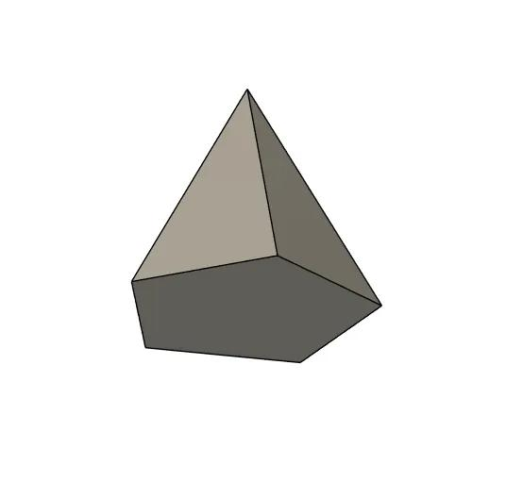
Irregular-base Pyramid
- Base is an irregular polygon.
- Base edges or angles are not all equal.
- Lateral faces may have different areas.
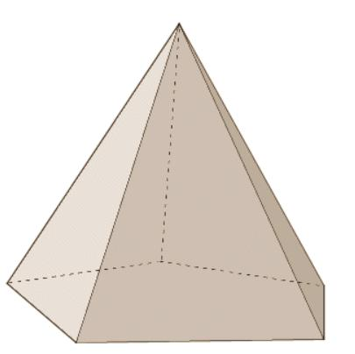
Regular-base Pyramid
- Base is a regular polygon.
- All base sides and interior angles are equal.
- When the apex is above the base center, lateral faces are congruent.
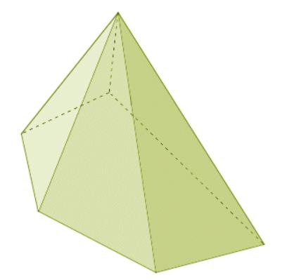
Oblique Pyramid
- Classified by the apex's position relative to the base.
- Its base may be regular or irregular.
- Its lateral faces generally differ in shape or size.

Applications
# Source: AI Source: Provided by: [Data Path: Persons Table -> ID Column: 1, Name_En Column: Motasem Essam] -> From: [ChatGPT] on [7/25/2026]
Irregular-base pyramids are useful in:
- Architecture: Modeling roofs and structures with non-symmetrical footprints.
- Engineering: Representing tapered components with irregular polygonal cross-sections.
- Computer graphics: Constructing 3D meshes with varied polygonal bases.
- Surveying and land modeling: Representing volumes formed over irregular polygonal regions.
- Mathematics education: Exploring how volume formulas apply independently of base regularity.

Key Points
# Source: AI Source: Provided by: [Data Path: Persons Table -> ID Column: 1, Name_En Column: Motasem Essam] -> From: [ChatGPT] on [7/25/2026]
- An irregular-base pyramid has an irregular polygon as its base.
- Its lateral faces are triangular regions meeting at a single apex.
- A pyramid with an $n$-sided base has $n+1$ faces, $2n$ edges, and $n+1$ vertices.
- The volume is $V=\frac{1}{3}Bh$, regardless of whether the base is regular.
- The lateral surface area is calculated by adding the areas of the individual triangular faces.
- The formula $A_{L}=\frac{1}{2}pl$ cannot generally be used unless the lateral faces share the same slant height.
- Base regularity and spatial orientation are separate classification properties.

Conclusion
# Source: AI Source: Provided by: [Data Path: Persons Table -> ID Column: 1, Name_En Column: Motasem Essam] -> From: [ChatGPT] on [7/25/2026]
An irregular-base pyramid is a polyhedron with an irregular polygonal base and triangular lateral faces meeting at a common apex. Unlike a regular-base pyramid, its base edges and angles are not all equal, and its lateral faces may have different dimensions. Nevertheless, its fundamental geometric relationships remain unchanged: its volume is one-third the base area multiplied by the perpendicular height, and its total surface area is the sum of its base and lateral face areas.

